Tribhuvan University

Institute of Science and Technology

AMRIT CAMPUS



Project Proposal

On

“Kishan Saathi”

A Crop Recommendation System

with integrated Farmer’s Marketplace

Submitted By:

Ashish Khatri (23123 / 076)

Nischal Kafle (23165 / 076)

Kritan Sitaula (23149 / 076)

Submitted To:

Department of Computer Science and Information Technology

Amrit Campus

Institute of Science and Technology

Tribhuvan University

Kathmandu, Nepal

2023

# Abstract

The proposed project is a web application which is aimed at revolutionizing agriculture sector with the help of technology. From this application, user will be able to predict the crops that is suitable to grown in the certain area by providing some soil data and weather data. Based on that our trained Machine Learning model will predict the crops that can be grown in that area. Not only that, our application will show high quality seed of that crop based on the recommendation by ML Model. After that user will be able to make purchase directly from our web application.

We believe because of this web application; the crop production will be maximized because most of the farmers in our country is unaware of the suitable crops that can be yield on their soil. They can barely recognize suitable crops that will give maximum production to sow on their soil. But with the help of this application, farmers will be easily able to identify the suitable crop to sow and maximize the production. Not only that, after production user will also be able to sell their produce online through this web application.

Due to integration of E-commerce functionality in our project, our project is also intended to solve another problem. That is, farmer’s will be able to get high return. As it happens quite often that in our country farmers has to protest because they couldn’t get deserving price for their produce but at the same time, we as a consumer are paying a lot for agricultural produce. This happens due to involvement of intermediaries. They buy farmer’s produce in low price which will be sent to wholesaler, and from wholesaler to retailer to finally sell to end consumer. In this process the price of the product grows exponentially. This process has to be followed because farmer cannot themselves expose their product in large market. But now we have technology which can brought people from different place to one place. And farmers could easily sell their product in deserving price. And also, consumer will get the same product in much low price and in much fresh condition as there is very low involvement of middlemen.

Hence this web application aims to empower farmers by leveraging the technology to make informed decisions about crop selection, seed purchasing and product selling. By combining Machine Learning, E-commerce and farmer-centric marketplace, the platform seeks to enhance agricultural productivity and streamline the agriculture supply chain.

# Table of Contents

Abstract i

Table of Contents ii

List of Figures iii

1: Introduction 1

1.1 Introduction 1

1.2 Problem Definition 1

1.3 Study of Existing Work 1

1.4 Proposed System 1

1.5 Objectives 2

2: Literature Review 3

3: Execution Strategy 4

3.1 Methodology 4

3.2 Scheduling 5

3.3 Feasibility 5

3.4 Tools to used 6

4: Basic Design Plan 7

4.1 Activity Diagram 7

4.2 Use Case Diagram 8

5: Expected Result 9

5.1 Authentication Module 9

5.2 User Module 9

5.3 Crop Recommendation Module 9

5.4 Seed Product Module 9

5.5 Consumer Product Module 9

5.6 Order Module 9

5.7 Conclusion 10

References 1

# List of Figures

Figure 1: Gantt Chart 5

Figure 2: Activity Diagram 7

Figure 3: Use Case Diagram of Kishan Saathi App 8

# 1: Introduction

## 1.1 Introduction

We are excited to present a proposal for an innovative web application aimed at revolutionizing agricultural practices by developing recommendation system for crop by analyzing soil nutrients. Also, farmers will be able to order seeds for that crop from same webapp. Also, they can sell their produce online in C2C market. By combining soil nutrient analysis-based crop recommendation system with an integrated marketplace, we aim to create an ultimate solution for enhancing productivity and profitability in the farming sector.

## 1.2 Problem Definition

Small scale farmers are unaware of maximizing their production with appropriate use of precise agriculture technique. We can implement a machine learning to train an AI which can predict the suitable seed and fertilizers to grow in the field by analysis of soil nutrients, temperature, moisture and humidity data. And recommend the suitable seeds and fertilizers to the farmers. Also cutting the effort to search the seeds and fertilizers, farmers can order these things online from the same app.

Also, there are very limited accessibility for farmers to effective market their product and generate deserving profit. They are forced to sell their products to middlemen, supplier who will supply to wholesale who will distribute to retailer and finally reach to consumer. This raises the price of product because of involvement of middlemen. At one side, farmers are not getting deserving return and at other side consumer has to pay expensive figures. With aim of solving this problem an idea emerges to create a virtual market for farmer who can sell their product directly in C2C market.

## 1.3 Study of Existing Work

Different e-commerce platform has been developed in Nepal to sell farmer’s good online such as Krishi COOP Bazaar. Also, different machine learning model has been developed in for prediction. Different work such as Regularized Greedy Forest to see an appropriate crop sequence at a given time stamps. Other research used historical records of meteorological data as training set where model is trained to spot climate that are deterrent for the assembly of crops which efficiently predicts the yield of crops on the idea of monthly weather patterns.

## 1.4 Proposed System

Our proposed system implements both e-commerce functionalities and machine learning models for crop recommendation and soil analysis. We also believed that not only either soil nutrients or weather data should be taken consideration for training the model but all the appropriate parameters such as temperature, rainfall, geography and soil condition to predict crop suitability.

## 1.5 Objectives

* To build a robust model to provide correct and accurate prediction of crop sustainability in a particular place for a particular soil type and climatic condition and recommend the seeds of that crop to buy online.
* To build an efficient C2C e-commerce platform to empower farmers.
* To build platform where farmers can exchange the machineries and supplies.
* To provide fertilizer recommendation based on soil nutrients and order it online.

# 2: Literature Review

In paper *“Smart Management of Crop Cultivation using IoT and Machine Learning” by Archana Gupta, Dharmil Nagda, Pratiksha Nikhare, Atharva Sandbhor*, author has proposed a smart system that can assist farmers in crop management by considering sensed parameters (temperature, humidity) and other parameters (soil type, location of farm, rainfall) that predicts the most suitable crop to grow in that environment.

In paper *“Crop Recommendation on Analyzing Soil Using Machine Learning” by Anguraj.Ka, Thiyaneswaran.Bb, Megashree.Gc, Preetha Shri.J.Gd, Navya.Se, Jayanthi. Jf*, author has proposed new technologies include the use of Internet of Things (IOT) and Machine Learning. The real time data from the field area can be collected using IOT system. The collected data from the field area is fed to the trained model. The trained model then makes the predictions using the data. The result produced by the model greatly helps is sowing the suitable crops in the particular field area.

In Reference paper *“Classification of Soil and Crop Suggestion using Machine Learning Techniques”, by A. Mythili*, determines a model is proposed for predicting the soil type and suggest a suitable crop that can be cultivated in that soil. The model has been tested using various machine learning algorithms such as KNN, SVM and logistic regression. The accuracy of the present model is maximum than the existing models.

In *“IOT based Crop Recommendation, Crop Disease Prediction and Its Solution” Rani Holambe, Pooja Patil, Padmaja Pawar, Saurabh Salunkhe, Mr. Hrushikesh Joshi*, proposed a system would assist the farmers in making an informed decision about which crop to grow depending on a variety of environmental and geographical factors. The ML and IoT based suggestions will significantly educate the farmer and help them minimize costs and make strategic decisions by replacing intuition and passed-down knowledge with far more reliable data-driven ML models. This allows for a scalable, reliable solution to an important problem affecting hundreds of millions of people.

# 3: Execution Strategy

## 3.1 Methodology

Below is general outline to execute this project:

1. Acquisition of Training Dataset:

For this system, we are using datasets all downloaded from Kaggle.

1. Data pre-processing:

This step includes replacing the null and 0 values for yield by -1 so that it does not affect the overall prediction. Further we have to encode the dataset so that it could be fed into our ML models.

1. Training Model:

We train models with Random Forest, Decision Tree, Support Vector Machine, and Logistic Regression to attain accuracy as high as possible. Jupyter Notebook will be used to train model.

1. Model Evaluation:

The models will be evaluated and one with higher accuracy will be saved as pkl.

1. Model Integrate with Webapp:

The most efficient ML model would be integrated with python web application which will predict the suitable crops based on user input of NPK value of soil and temperature data fetch from open weather map API. Python with flask will be used.

1. Backend development for E-Commerce functionality:

Finally, after completion of ML functionality, we will start working on other major functionality.

We have planned to use MERN (MongoDB as database, Express as framework, React as frontend technology and Node as runtime environment) Stack because of its flexibility and team expertise.

We are going to use MVC pattern project architecture and modular folder architecture.

A basic outline of Functional Requirement is drawn below:

* Authentication Module:

-Registration as farmer or consumer, Verification, Login with JWT, Logout, Reset Password

* Banner Module:

-CRUD for dynamic and admin-controlled banner

* Seed Module:

-CRUD for Seed product to sell by supplier in our web-application (admin controlled)

* Consumer Product Module:

-CRUD for consumer product to sell by farmer (farmer role controlled)

* Order Module:

-Order module to manage carts and order details

1. Frontend development

Along with Backend development, we are going to use React JS for frontend development with appealing and user-friendly User Interface.

## 3.2 Scheduling

Estimated time spent in the development of this application is 4 months and scheduled as:

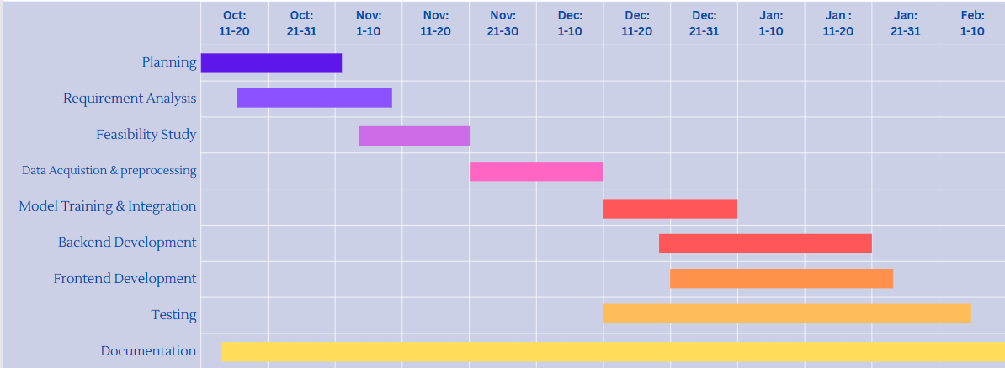

Figure : Gantt Chart

## 3.3 Feasibility

* Technical Feasibility:

Technically, we can train model to predict suitable crops using different algorithm like SVM, or random forest whichever provides higher accuracy with python and other basic functionality can be implemented using MERN Stack technology.

* Economic Feasibility:

Software requirement for development of this project is available free for community development. However, hardware requirement might be high to setup IOT as we might need NPK sensor for soil nutrient, moisture sensor for moisture measurement in soil, Arduino board, etc. But as for now this project is just a prototype so we are going to take all these parameters through user and weather data through online free APIs like open weather map. So, for prototyping, this project is economically feasible.4

* Operational Feasibility:

As it is a web application that can be deployed in web which can be accessed by any user with internet connection. Hence, it is operationally feasible.

## 3.4 Tools to used

1. Jupyter Notebook: The Jupyter Notebook is the original web application for creating and sharing computational documents. It offers a simple, streamlined, document-centric experience. This will be used to data analysis and train the model in our project.
2. Microsoft Visual Studio: Visual Studio Code is a free, open source, and cross-platform code editor that supports many languages and features. We will use this IDE for this project.
3. Postman: Postman is a comprehensive API platform that simplifies each step of the API lifecycle and streamlines collaboration for better APIs. We will use this to test APIs.
4. GitHub: GitHub is a Git hosting service, but it adds many of its own features. It provides

access control and several collaboration features, such as wikis and basic task management tools for every project. This will helpful for collaborative contribution in our group project.

1. Draw.io: For drawing charts and figures.
2. Browser: MS Edge and Google charts can be used for testing frontend and backend integration.

Other tools might also be needed and used according to need.

# 4: Basic Design Plan

## 4.1 Activity Diagram

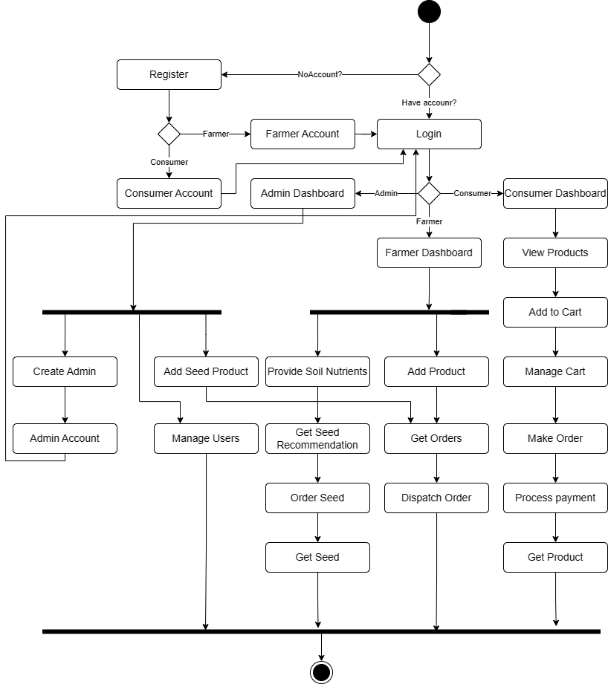

Figure : Activity Diagram

## 4.2 Use Case Diagram

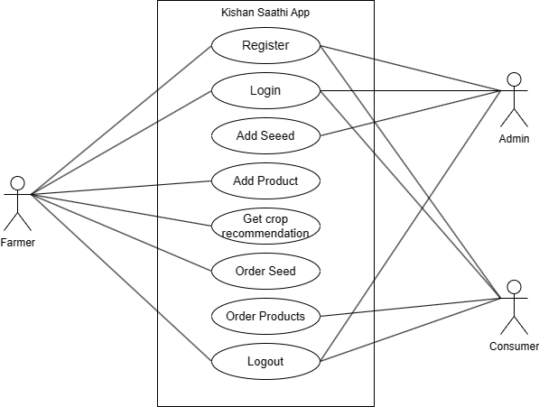

Figure : Use Case Diagram of Kishan Saathi App

# 5: Expected Result

## 5.1 Authentication Module

* Register: After Registration, we expect user data to be stored in database’s User’s collection.
* Verification: We expect user to get verification Link and after verification, user should be able to set password which will be stored in database in encrypted form.
* Login: User should be logged in with his/her correct email and password which will verified through comparison with credentials in database. And Personal Access Token will be stored in PAT collection of databases which will be used to verify the login in any attempt to access APIs.
* Logout: After logout, Personal Access Token will be deleted from database and user will no longer be able to access any other content.
* Forget Password: User should receive verification link in their email and they will be able to reset password.

## 5.2 User Module

* Admin will be able to access the list of all users.
* Admin should able to create other admin.
* Admin should be able to update and delete any user’s detail.
* Any users should be able to update their own profile.

## 5.3 Crop Recommendation Module

* User will be provided with a form to enter NPK value, rainfall value, pH value and city.
* Module will fetch humidity and temperature data from open weather map API.
* Based on NPK, rainfall, pH, temperature and humidity data, trained ML model will predict the suitable crops to be grown.
* The Seed product from seed product module will be recommended to user according to prediction.

## 5.4 Seed Product Module

* Admin user will be able to add, update or delete seed product.
* Farmer will be able to read active products and make orders.

## 5.5 Consumer Product Module

* Farmer will be able to add, update or delete consumer product.
* Consumer will be able to read product and make orders.

## 5.6 Order Module

* Any order will be managed from this module.
* Quantity can be altered.
* Order can be placed successfully which will notify seller.
* Online payments can be added.

## 5.7 Conclusion

In conclusion, the proposed web application project is a comprehensive solution for the agricultural industry, to address key challenges faced by farmers. By harnessing predictive analytics to recommend crops based on soil NPK values and facilitating seamless online seed purchasing from the same platform, this project aims to optimize crop selection processes and streamline access to essential agricultural resources.

Moreover, the integration of a farmer-centric marketplace within the platform creates a unique ecosystem where farmers can showcase and sell their produce directly to buyers, eliminating intermediaries and fostering a direct connection between producers and consumers. This not only empowers farmers by providing them with a broader market reach but also allows consumers to access fresh produce more efficiently.

By embracing technology and innovation, this web application aims to revolutionize traditional agricultural practices, promoting sustainability, efficiency, and economic growth within the agricultural sector.

# References

1. 2019 IEEE “Smart Management of Crop Cultivation using IoT and Machine Learning” Archana Gupta, Dharmil Nagda, Pratiksha Nikhare, Atharva Sandbhor
2. “Crop Recommendation on Analyzing Soil Using Machine Learning” Anguraj.Ka, Thiyaneswaran.Bb, Megashree.Gc, Preetha Shri.J.Gd, Navya.Se, Jayanthi. Jf, 2020.
3. “Classification of Soil and Crop Suggestion using Machine Learning Techniques”, A. Mythili, IEEE 2019.
4. “IOT based Crop Recommendation, Crop Disease Prediction and Its Solution” Rani Holambe, Pooja Patil, Padmaja Pawar, Saurabh Salunkhe, Mr. Hrushikesh Joshi, 2019 IRJET